Door Ajar Chime – For Fixed Telltale Applications Without Message Center Warnings GGEA 1.3

Functional Description

The purpose of the Door Ajar Chime is to alert the driver that a closure is ajar while in Normal Mode, and vehicle speed has equaled or exceeded 5 km/h. This STSS is ONLY used for fixed telltale applications where no message center warnings are used.

The Door Ajar chime correlates the DrStatDrv_B_Actl signal, the DrStatPsngr_B_Actl signal, the DrStatRr_B_Actl signal, the DrStatRl_B_Actl signal, the DrStatTgate_B_Actl, and the DrStatInnrTgate_B_Actl signal from the BCM and the Operational_Mode in order to request Chime Arbitrator to sound the Door Ajar Chime.

Note: Hood Ajar signal DrStatHood_B_Actl is intentionaly not used for telltale only applicatons (no associated text messages) because using the Door Ajar Telltale for the hood ajar condition without clarifying text messages leads to TGW and persons returning vehicles for service as it is not intuitive the Door Ajar Telltale is on due to the hood ajar condition without the clarifying message.

Chimes Arbitrator function is defined in the Chimes – Chime Arbitrator section of this SPSS.

Interfaces

Interface Context Diagram (I/O Block Diagram)

Figure 1.0 Door Ajar Chime Funciton
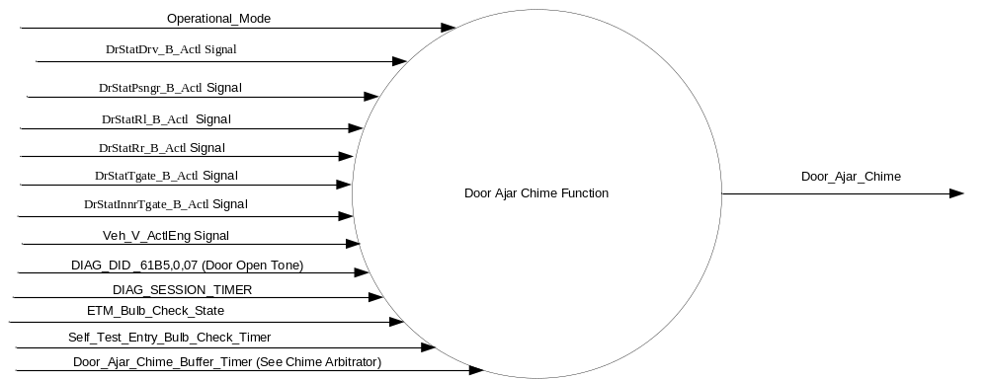

Inputs
      - INTERNAL:
            - DIAG_SESSION_TIMER
            - Operational_Mode
            - Self_Test_Entry_Bulb_Check_Timer
            - Door_Ajar_Chime_Buffer_Timer (See Chime Arbitrator)

      - MUX message on the CAN Bus

- DrStatDrv_B_Actl Signal
Signal Name | Size (bits) | Detail | Units | Res. | Offset | State  Encoded | Min | Max
DrStatDrv_B_Actl | 1 |  | SED | 1 | 0 |  | 0 (0x0) | 1 (0x1)
 |  | Closed |  |  |  | 0x0
 |  | Ajar |  |  |  | 0x1

- DrStatPsngr_B_Actl Signal
Signal Name | Size (bits) | Detail | Units | Res. | Offset | State  Encoded | Min | Max
DrStatPsngr_B_Actl | 1 |  | SED | 1 | 0 |  | 0 (0x0) | 1 (0x1)
 |  | Closed |  |  |  | 0x0
 |  | Ajar |  |  |  | 0x1

- DrStatRl_B_Actl Signal
Signal Name | Size (bits) | Detail | Units | Res. | Offset | State  Encoded | Min | Max
DrStatRl_B_Actl | 1 |  | SED | 1 | 0 |  | 0 (0x0) | 1 (0x1)
 |  | Closed |  |  |  | 0x0
 |  | Ajar |  |  |  | 0x1

- DrStatRr_B_Actl Signal
Signal Name | Size (bits) | Detail | Units | Res. | Offset | State  Encoded | Min | Max
DrStatRr_B_Actl | 1 |  | SED | 1 | 0 |  | 0 (0x0) | 1 (0x1)
 |  | Closed |  |  |  | 0x0
 |  | Ajar |  |  |  | 0x1

- DrStatInnrTgate_B_Actl Signal
Signal Name | Size (bits) | Detail | Units | Res. | Offset | State Encoded | Min | Max
DrStatInnrTgate_B_Actl | 1 |  | SED | 1 | 0 |  | 0 (0x0) | 1 (0x1)
 |  | Closed |  |  |  | 0x0
 |  | Ajar |  |  |  | 0x1

- DrStatTgate_B_Actl Signal
Signal Name | Size (bits) | Detail | Units | Res. | Offset | State Encoded | Min | Max
DrStatTgate_B_Actl | 1 |  | SED | 1 | 0 |  | 0 (0x0) | 1 (0x1)
 |  | Closed |  |  |  | 0x0
 |  | Ajar |  |  |  | 0x1

- Veh_V_ActlEng Signal
Signal Name | ID | Size (bits) | Pos. (bits) | Detail | Units | Res. | Offset | State  Encoded | Min | Max
Veh_V_ActlEng | 0x201 | 16 | 16 |  | KPH | 0.01 | 0 |  | -0  (0x0000) | 655.35 (0xFFFF)

Outputs
- Door_ Ajar_Chime_Status_Flag

Function/Performance

Operational Modes

Mode | Differentiating Vehicle Conditions
Sleep Mode | Door_Ajar_Chime_Status_Flag = False
Limited Mode | Door_Ajar_Chime_Status_Flag = False
Normal Mode | Door_Ajar_Chime_Status_Flag = True / False
Crank Mode | Door_Ajar_Chime_Status_Flag = True / False

Voltage Levels

Refer to the Cluster Features Table located in the Operational Modes and Voltage Range Strategies section of this SPSS

Human-Machine Interface

Visual

Indicator Graphics / Display Format


For actual symbol definition refer to database # K.08 of the 03-0685 ARL requirement

Indicator Color Coordinates

Red - Reference SDS IL-0017/IS-0379

Indicator Characteristics

LED - Door Ajar Telltale

Audio

Refer to Audio Section in Chimes & Chime Arbitrator SPSS Section

Switch Control Logic

Not Applicable

System Accuracy

- The state of this chime flag shall change within 100 msec of a state change as indicated in the state matrix found in section 1.3.5.1 of this document
- Refer to System Accuracy in Chimes & Chime Arbitrator SPSS Section

Operation: Performance and Functional

Subsystem Algorithm Flowchart / State Diagram

- State Matrix for Door Ajar Chime
Operational_Mode | DIAG_  SESSION_TIMER | DIAG_DID_61B5,0,07 | DF_Door_  Ajar_RTT | PF_Door_  Ajar_RTT | DR_Door_  Ajar_RTT | PR_Door_  Ajar_RTT | LG_Door_  Ajar_RTT |  | Trunk_  Ajar_RTT |  | Hood_  Ajar_RTT | Door_Ajar_Chime_Status_Flag
Normal | Active | Active (0x1) | X | X | X | X | X | X |  | X |  | True (0x1)
All Other Cases |  |  |  |  |  |  |  |  |  |  |  | As Per Figure 2
X = Don’t Care

Figure 2 State Diagram For Door Ajar Chime Without Message Warnings

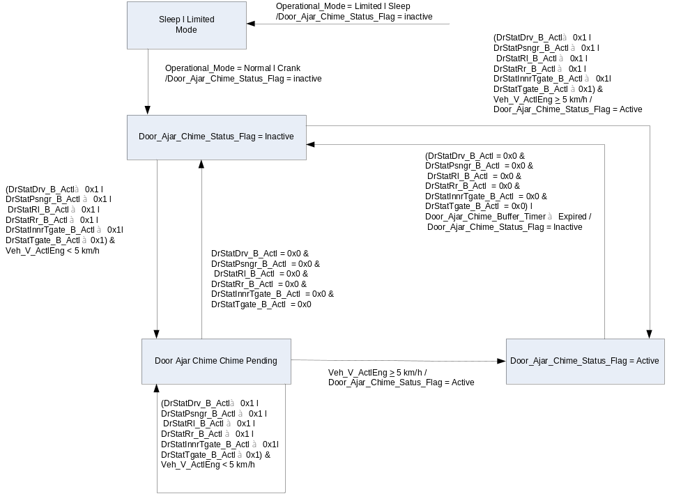

Operation Description (supports algorithm flowchart /state diagram)

- The Door Ajar Chime does not sound for a hood ajar condition when implemented with a fixed Telltale with no message center warning capability. This is because in prior application when Hood Ajar signal activated the Door Ajar Tellale / Chime without a clarifying text message persons did not understand why the door ajar telltale was illuminated nor why the Door Ajar Chime sounded and assumed a malfunction occurred.

Function Safety Classification (EMC)

Class B

Memory Storage

Parameter Name | Description | Value at  Battery Connect | Value at  Module Wake-up
Door_Ajar_Chime_Status_Flag | Informs the Chime Arbitrator when a chime needs to be played | False | False
Door_Ajar_Chime_Trigger | Internal Flag used to set Door_Ajar_Chime_Status_Flag under certain conditions. | Inactive | Inactive
Door_Ajar_Chime_Buffer_Timer | Timer used by Chime Arbitrator | See Chime Arbitrator Section
DrStatDrv_B_Actl Signal | Input Signal sent from the BCM | Closed (0x0) | Closed (0x0)
DrStatPsngr_B_Actl Signal | Input Signal sent from the BCM | Closed (0x0) | Closed (0x0)
DrStatRl_B_Actl Signal | Input Signal sent from the BCM | Closed (0x0) | Closed (0x0)
DrStatRr_B_Actl Signal | Input Signal sent from the BCM | Closed (0x0) | Closed (0x0)
DrStatInnrTgate_B_Actl Signal | Input Signal sent from the BCM | Closed (0x0) | Closed (0x0)
DrStatTgate_B_Actl Signal | Input Signal sent from the BCM | Closed (0x0) | Closed (0x0)
Veh_V_ActlEng Signal | Vehicle speed as received over CAN | 0x0 | 0x0
DIAG_DID_61B5,0,07 (Door Open Tone) | Sounder Output, parameter 0, state 07 (Door Open Tone) | No Sound (0x00) | No Sound (0x00)
Operational_Mode | 4 state indicator for cluster operational mode | Limited | Limited or Normal or Crank

Parameter Name | Description | Value at  Battery Connect | Value at  Module Wake-up
DIAG_SESSION_TIMER | Timer used to time-out a diagnostic session | Not Active | Not Active
Self_Test_Entry_Bulb_Check_Timer | Timer used in diagnostic session to do a self check of telltales | Not Active | Not Active

Prove Out

No

Reconfigurable Telltale

No

Message Center Msg

See Message Center Function

Error Handling

Missing Message Strategy

The signals will be declared missing as per the Diagnostics section of this SPSS.

DTCs states and history will be determined as per the Diagnostics section of this SPSS.

Diagnostics

Self Test

Bulb illuminated during self test as per Self_Entry_Bulb_Check_Timer

Engineering Test Mode

Reference section “Dealer / Engineering Test Mode (ETM)”

Part II Performance

Supported Diagnostic DEDs (Service $22 and $2F)
Number | PID / CommonID Name | PID Type
61B5 | Sounder Output, parameter 0, state 07 (Door Open Tone) | State Encoded

Supported Diagnostic Trouble Codes (DTCs)
DTC | Description
None | See Door Ajar Telltale Section

Reference Specification

EF-0027 SAFETY – DOOR AJAR WARNINGTONE/INDICATOR

IS-0001 WARNINGS/INDICATORS/DISPLAYS PROVEOUT
IS-0046 INSTRUMENTATION MATERIAL RESISTANCE TO CLEANING
IS-0052 OPERATING VOLTAGES - FUNCTIONAL/PERFORMANCE
IS-0069 FUNCTIONAL IMPORTANCE CLASS
IS-0324 WINDSHIELD & OTHER REFLECTIONS
IS-0327 WARNING INDICATOR EVALUATION
IS-0329 FLICKERING OF LAMPS
IS-0379 NORTH AMERICAN WARNINGS AND INDICATORS STRATEGY

IL-0017 TELLTALE AND INTERIOR ILLUMINATION COLOR
IL-0021 CRAFTSMANSHIP - DISPLAYS
IL-0023 CLARITY/LEGIBILITY/READABILITY
IL-0025 INTERIOR ILLUMINATION INTENSITY
IL -0027 VISUAL CONTRAST
IL -0043 OPERATIONAL ENVIRONMENT FUNCTIONALITY
IL -0045 COLOR
IL -0047 TELLTALE; INDICATOR AND DISPLAY LIGHT INTENSITY
IL -0048 ILLUMINATION ACCEPTABILITY

03-0661 PLACEMENT: CONTROL AND DISPLAY LOCATIONS
03-0662 PLACEMENT: LOGICAL GROUPING FUNCTION AND USAGE
03-0664 PLACEMENT: DOWN VISION TO COMPONENTS WITH HIGH VISUAL DEMAND
03-0665 PLACEMENT: EXPECTED LOCATIONS OF CONTROLS AND DISPLAYS VDS
03-0670 INTERIOR VISIBILITY
03-0671 INTERIOR VISIBILITY: REFLECTIONS FROM COMPONENTS & SURFACES
03-0672 INTERIOR VISIBILITY: REFLECTIONS IN DISPLAYS
03-0673 INTERIOR VISIBILITY: VISUAL OBSCURATIONS
03-0674 INTERIOR VISIBILITY: ILLUMINATION CONTROLS / DISPLAYS
03-0675 INTERIOR VISIBILITY: VEILING GLARE
03-0677 INTERIOR VISIBILITY: SUNLIGHT WASHOUT
03-0681 IDENTIFICATION: CHARACTER AND SYMBOL SIZE
03-0682 IDENTIFICATION: LEGIBILITY
03-0685 IDENTIFICATION: SYMBOLS, ABBREV FOR CONTROL
03-0721 LOGIC OF OPERATION: OPERATIONAL STEREOTYPES
03-0722 LOGIC OF OPERATION: INTERPRETATION
03-0723 LOGIC OF OPERATION: USE OF SYSTEMS WITH VISUAL DISPLAYS

Revision History

SPSS Module Revision History

Revision Level | Name | Change Description | Date
1.0 | J.Blatchford | Initial Release | 7/16/13

